**HANDSON USER-DEFINED FUNCTION**

**Tables: Features, Sales, Stores**

**Scalar Valued Function:**

A Scalar valued function will take one or many inputs and returns a single value whenever the function is invoked.

1. **Create a user-defined function to convert the temperature to Fahrenheit.**

**//Scalar Valued Function Creation**

create function fahrenheit (@val float)

returns float

as

begin

return (@val * 1.08)+32

end

**//To call the function**

select *, dbo.fahrenheit(Temperature) as Fahrenheit from Features

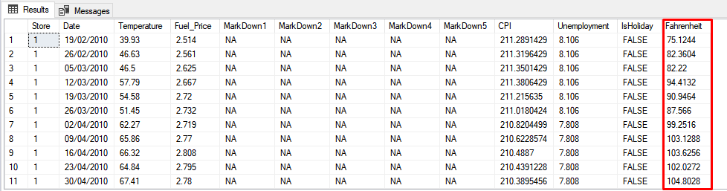

**Table Valued Function:**

A Table valued function can be created with or without parameters and returns a table data whenever the function is invoked.

1. **Create a user-defined function for the Stores table to fetch the size for only type ‘A’.**

**//Table Valued Function Creation with Parameter**

Create function Type_A (@type varchar(5))

returns table

as

return

select * from Stores where Type=@type

**//To call the function**

select * from Type_A('C')

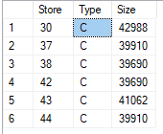

**//To call the function**

select * from Type_A('C')

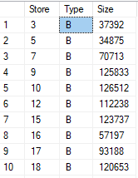

1. **Create a user-defined function for the Sales table to fetch the Holiday data only for department 77.**

**//Table Valued Function Creation without Parameter**

create function Holiday(@dept int)

returns table

as

return

select * from Sales where Dept=@dept and IsHoliday='TRUE'

**//To call the function**

select * from dbo.Holiday(77)

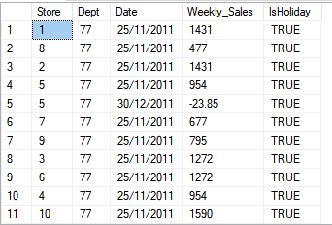

**COALESCE()**

The Coalesce will return the first non-null value in the record.

1. **Create a Coalesce to replace the null value as No data in the MarkDown1 column.**

**//Table Valued Function Creation using Coalesce**

CREATE FUNCTION New_Coalesce (@markdown1 varchar(20))

RETURNS table

AS

Return

SELECT *,COALESCE(Null,'No Data')as New_Column from Features

**//To call the function**

select * from dbo.New_Coalesce('NA')

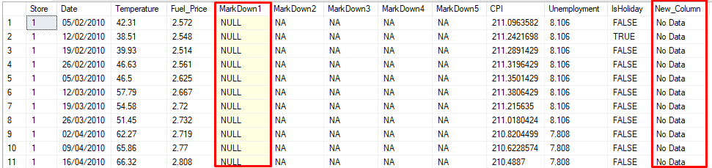

1. **Drop all the functions.**

drop function fahrenheit

drop function Type_A

drop function Holiday

